Create a Cycle Count file

Start CycleCount



1. After 10-30 seconds Window will pop up as follows

Step 1) Select Storage type or the application not going to work

Step 2) Select level

Step 3) Add desired bin’s quantity

1. Navigate to S:\Warehouse dept\Inventory control\Reporting and dashboards\Cycle_Count\CycleCounting\GENERATED BINS, and you will find your file in format.xlsx



UPDATE Cycle Count

Start S:\Warehouse dept\Inventory control\Reporting and dashboards\Cycle_Count



1. After 10-30 seconds Window will pop up as follows

Step 1) Click on the button

Step 2) Window will pop up and navigate to .xlsx file

* Select it and click open
* In current state to work requires column Storage Bin

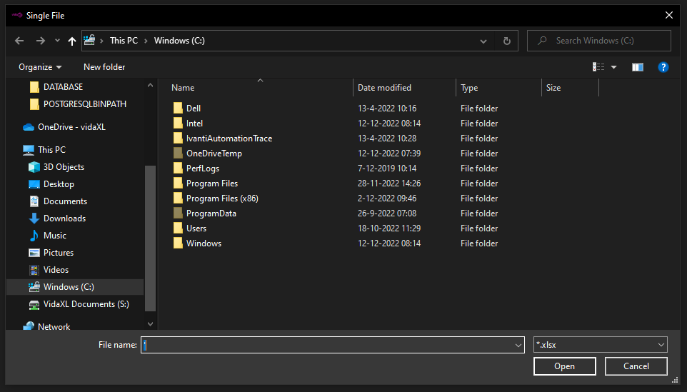

REPORT’s Cycle Count

Start S:\Warehouse dept\Inventory control\Reporting and dashboards\Cycle_Count



1. After 10-30 seconds Window will pop up as follows

Step 1) MKI report

Step 2) JTS1 report

Step 3) JTS2 report

1. To see the report by Storage type, navigate to

1. Select the folder report will be inside in .pdf format